**SPRINT – 1**

|  |  |
| --- | --- |
| **Date** | 30 October 2022 |
| **Team ID** | PNT2022TMID00928 |
| **Project Name** | Smart waste management system for metropolitan cities |
| **Story points** | 20 |

Step-1: To Create IBM Cloud

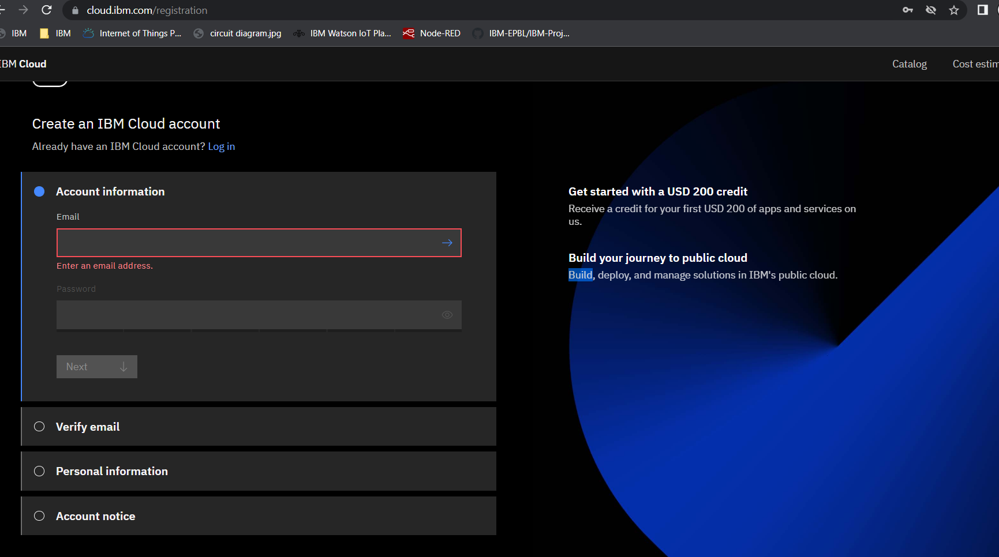

Step-2 : Login to IBM Cloud Account

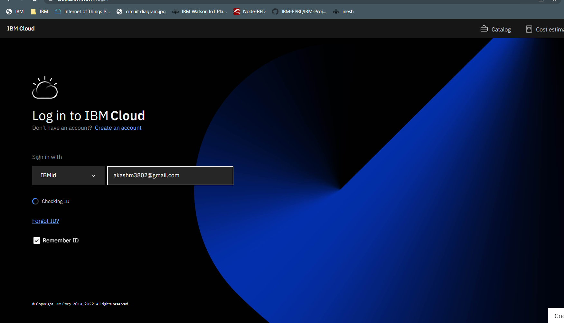

Step-3: Using IBM CLOUD services for the Project

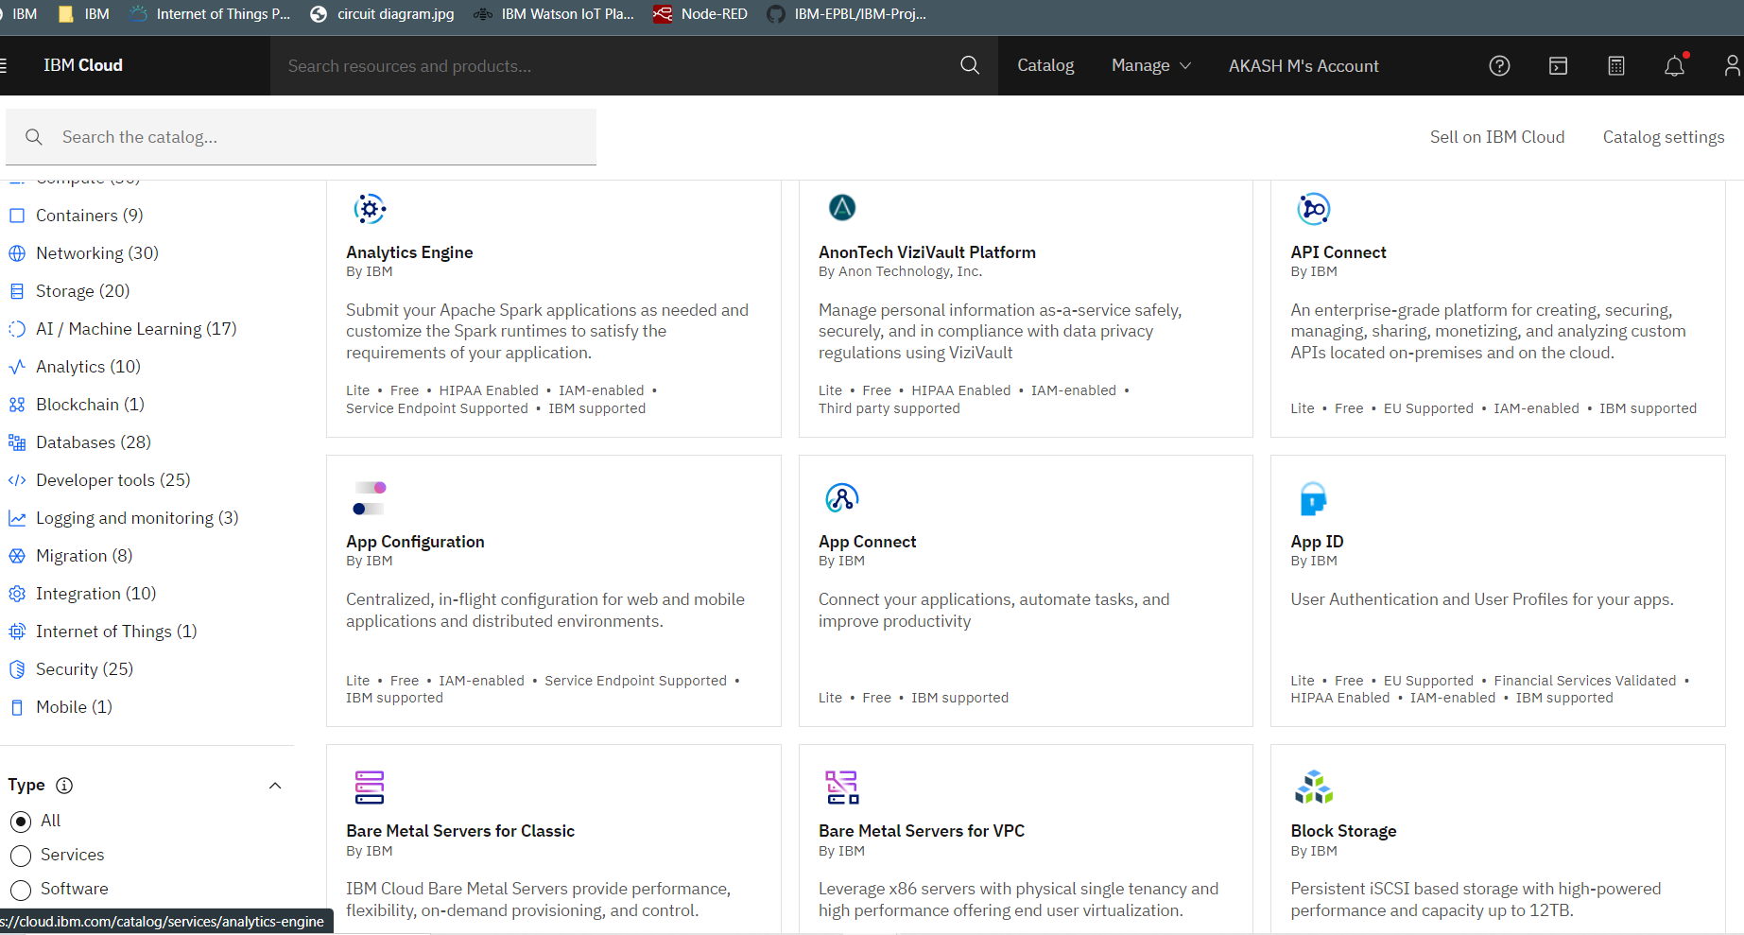

Step – 4 : configure IBM Watson IOT platform

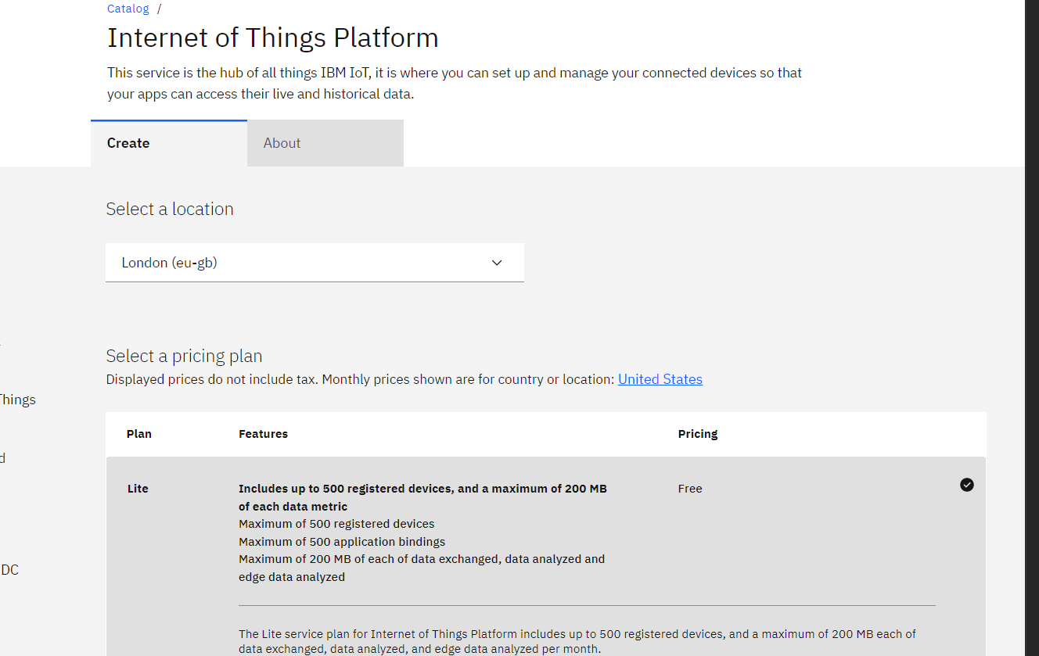

Step – 5 : IBM Watson IOT platform is created

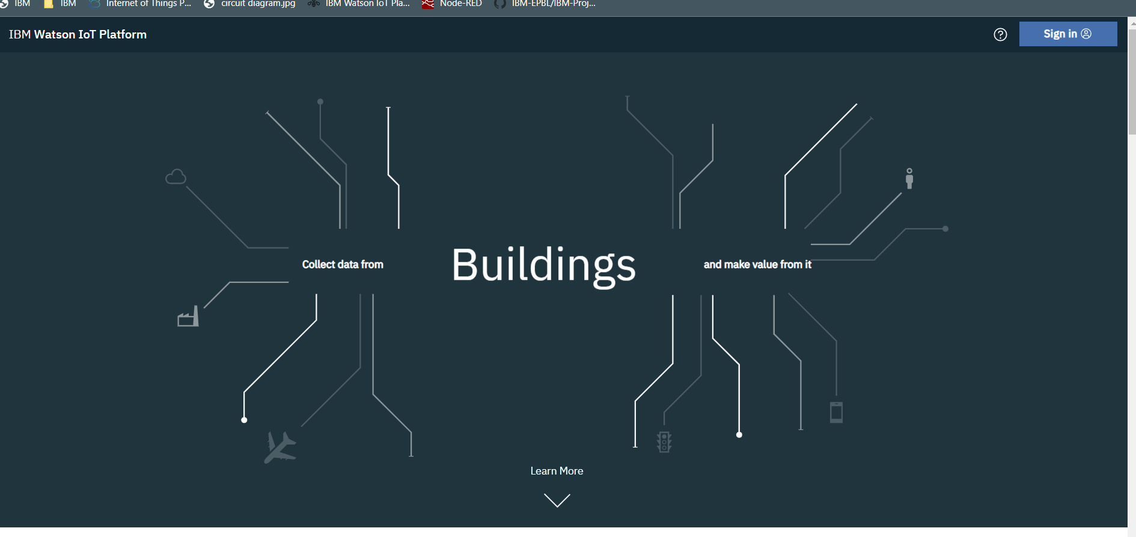

Step – 6 : Sign in to IBM Watson IOT platform

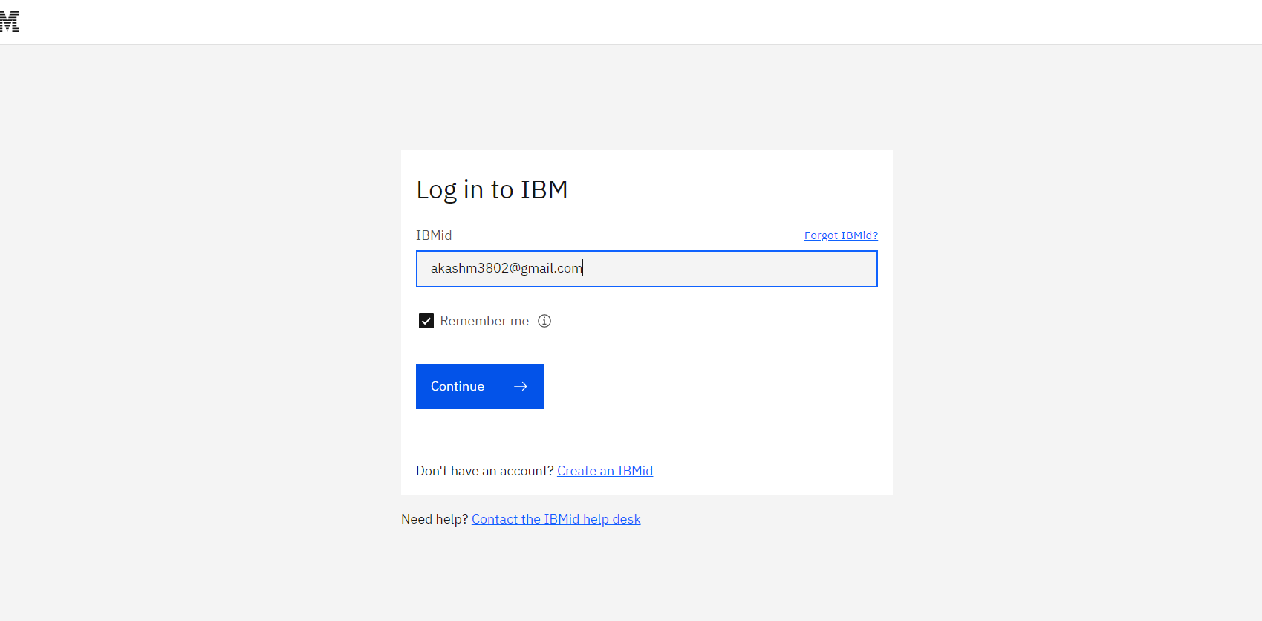

Step – 7 : Open IBM Watson IOT platform

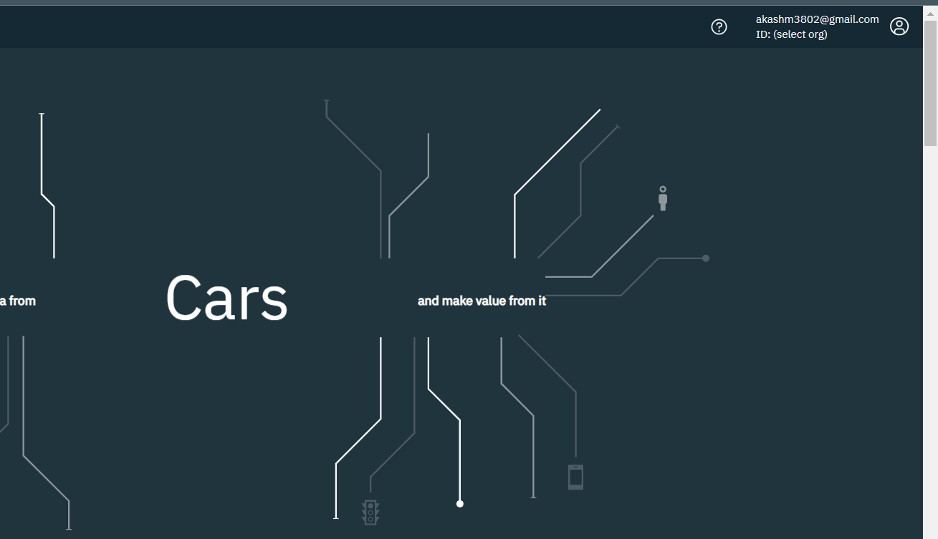

Step – 8 : Add the team members to access the devices.

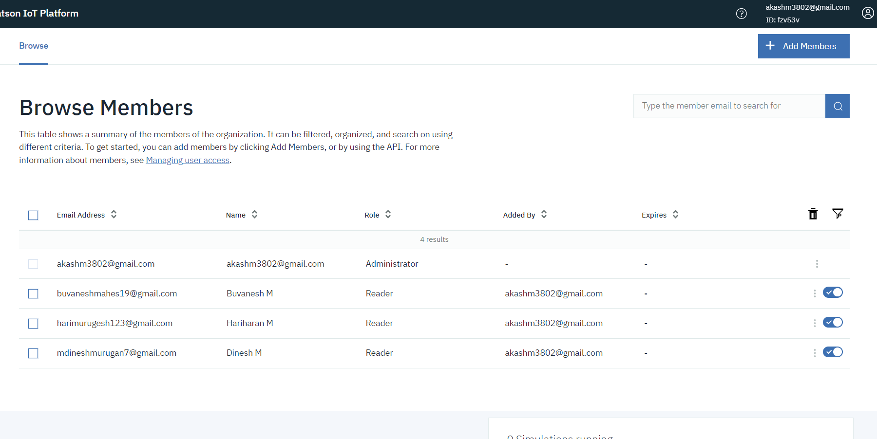

Step – 9 : to connect the IOT device to the IBM cloud , create device in the IBM Watson IOT Platform and get the device credentials

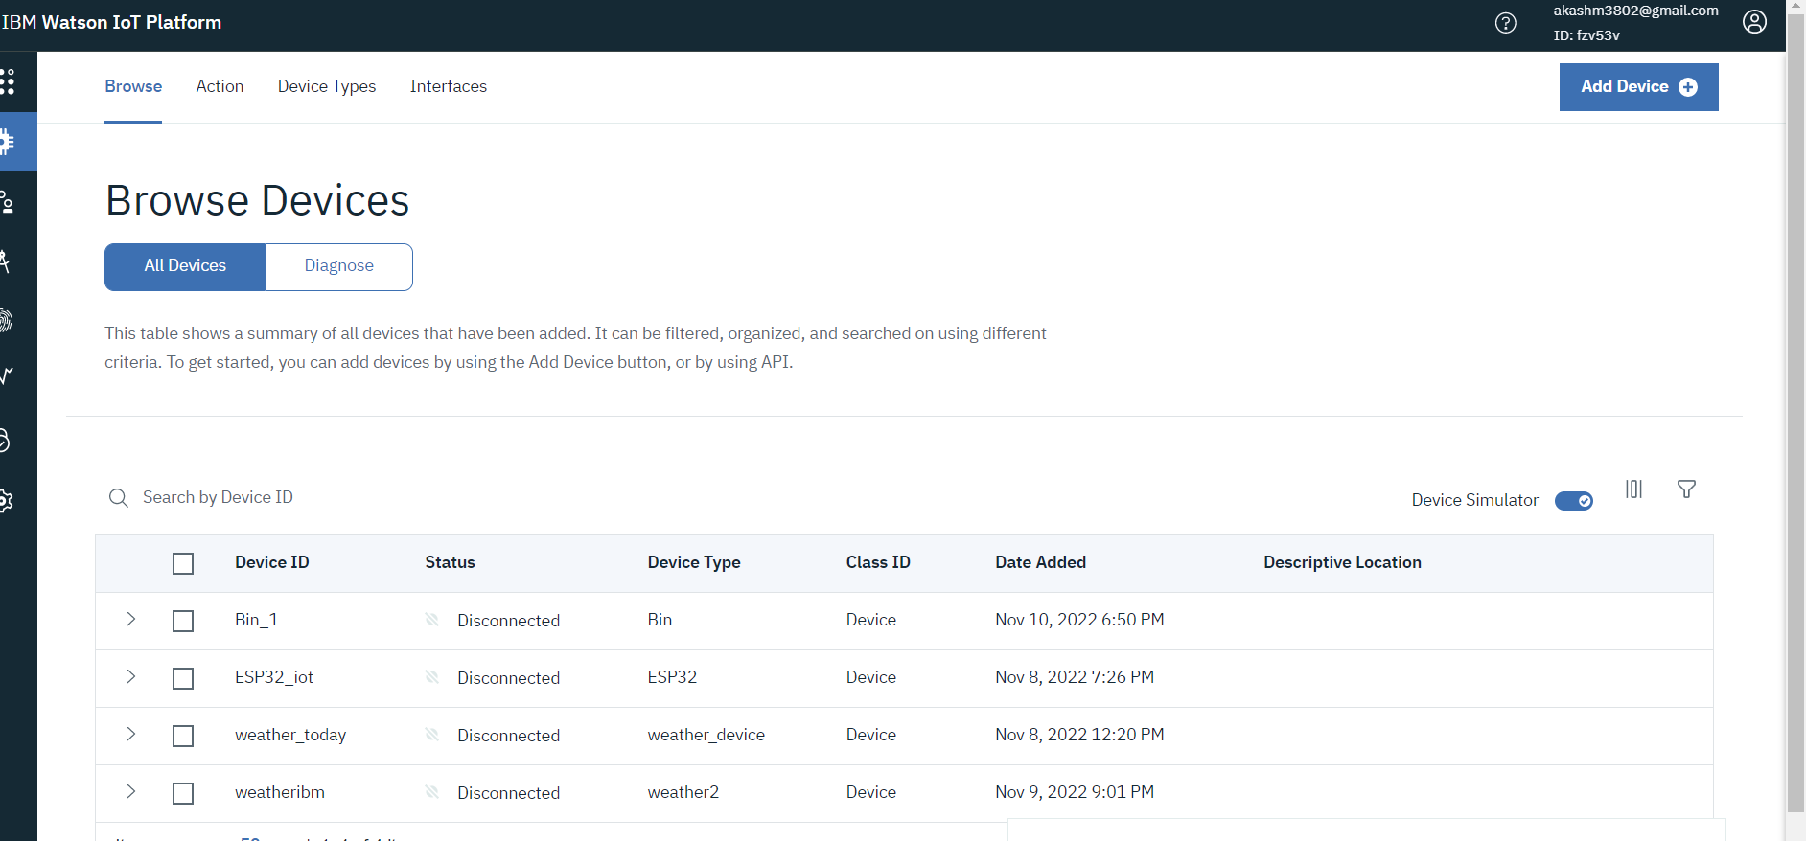

Step – 10 : Connect the device with IOT device and start simulating.

